|  |  |  |  |  |  |  |  |  |  |  |  |  |  |  |  |  |  |  |  |  |  |  |  |  |  |  |  |  |  |  |  |  |
| --- | --- | --- | --- | --- | --- | --- | --- | --- | --- | --- | --- | --- | --- | --- | --- | --- | --- | --- | --- | --- | --- | --- | --- | --- | --- | --- | --- | --- | --- | --- | --- | --- |
| **TRIUMPHANT COLLEGE**   |  |  |  |  | | --- | --- | --- | --- | | **NAMES** | Tusnelde Laina Shagwana Endjala | | | | **STUDENT NUMBER** | 2021028012 | | | | **COURSE** | Information Technology | | | | **SUBJECT** | Advanced Web Design | | | | **YEAR** | 2023 | | | | **DUE DATE** | 16 October | | | | **EMAIL ADDRESS** | tusnelde9@gmail.com | | | | **PHONE NUMBER** | 081 3899663 | **FIRST SEMESTER :2** | **ASSIGNMENTS NO. 2** | |



|  |  |  |  |
| --- | --- | --- | --- |
| FOR OFFICIAL USE ONLY  FINAL MARKS |  |  |  |

**By submitting this assignment for evaluation, I acknowledge that the assignment is my own work, and where the work of others has been used it has been appropriately cited and referenced**.

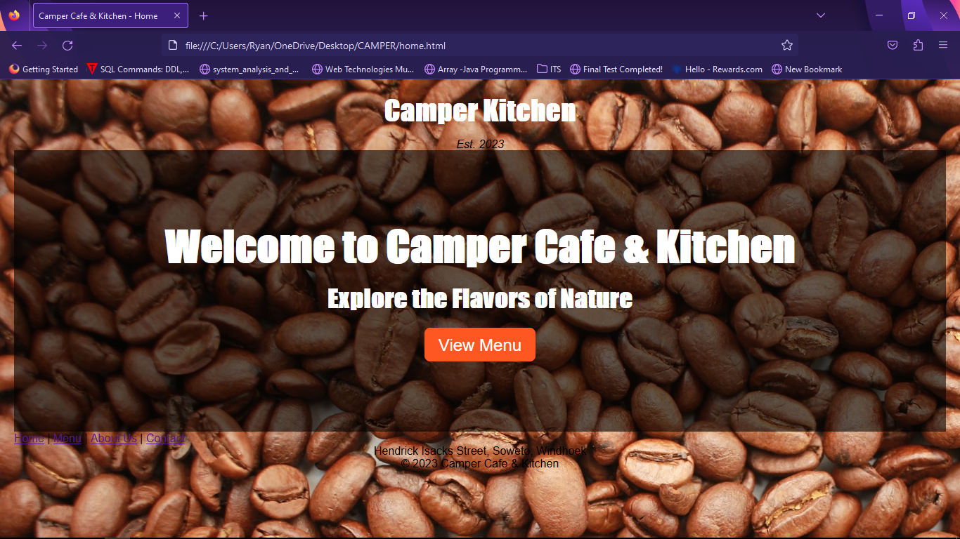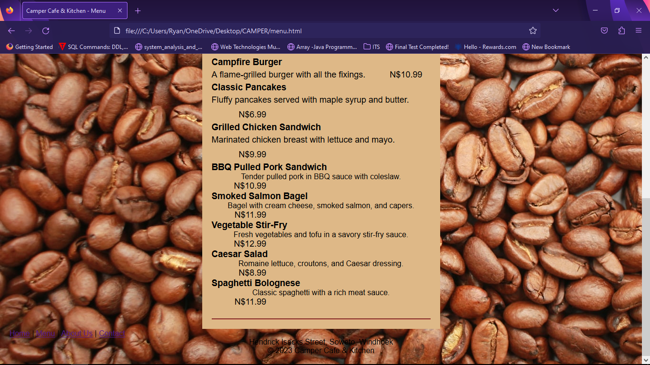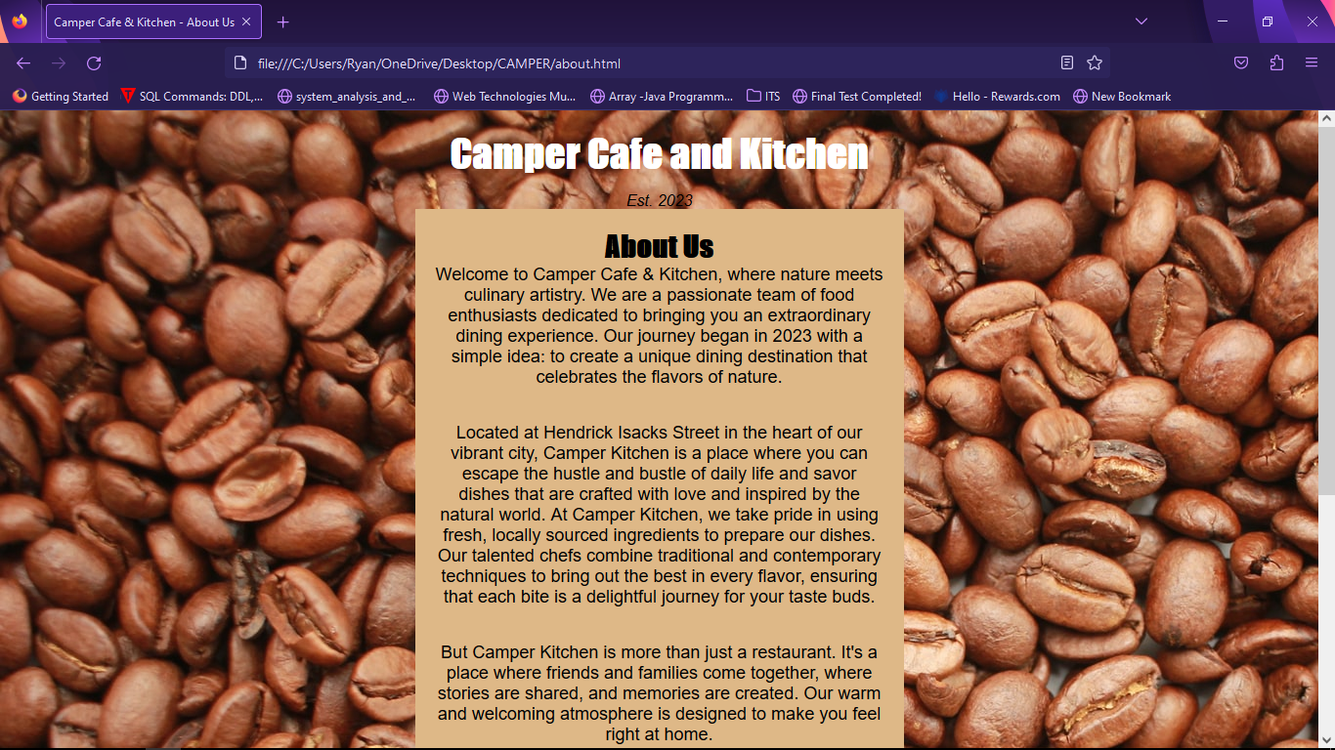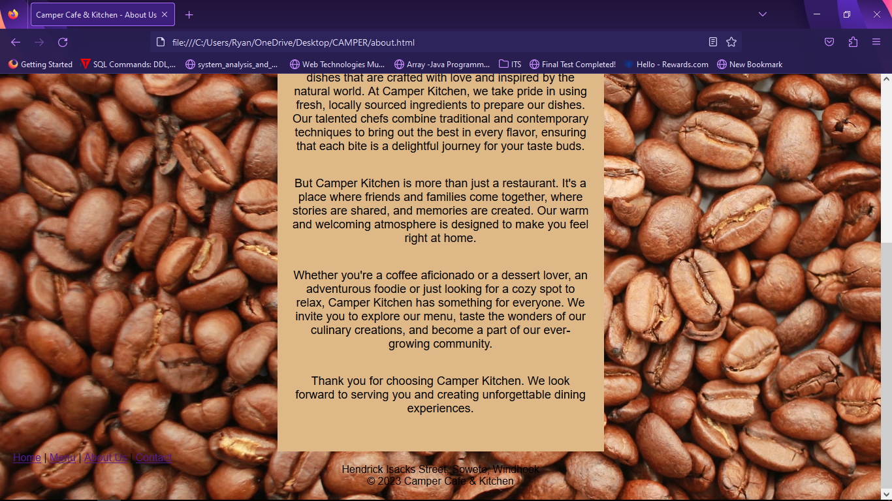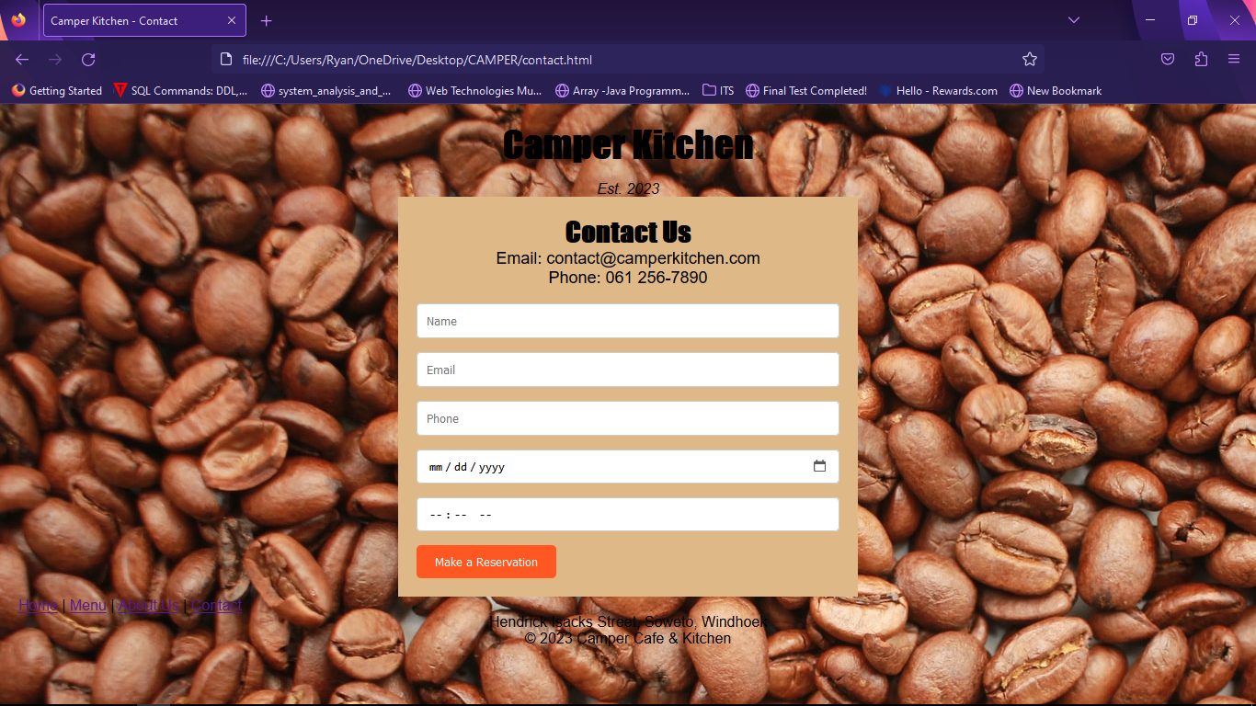

**HTML and CSS code for all the pages**

**Home Page Code**

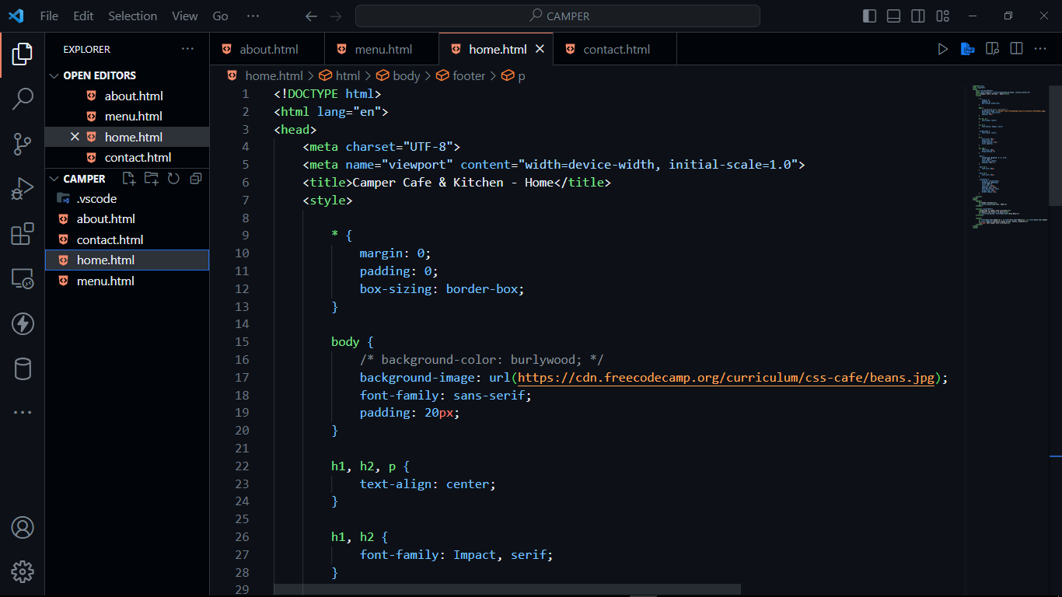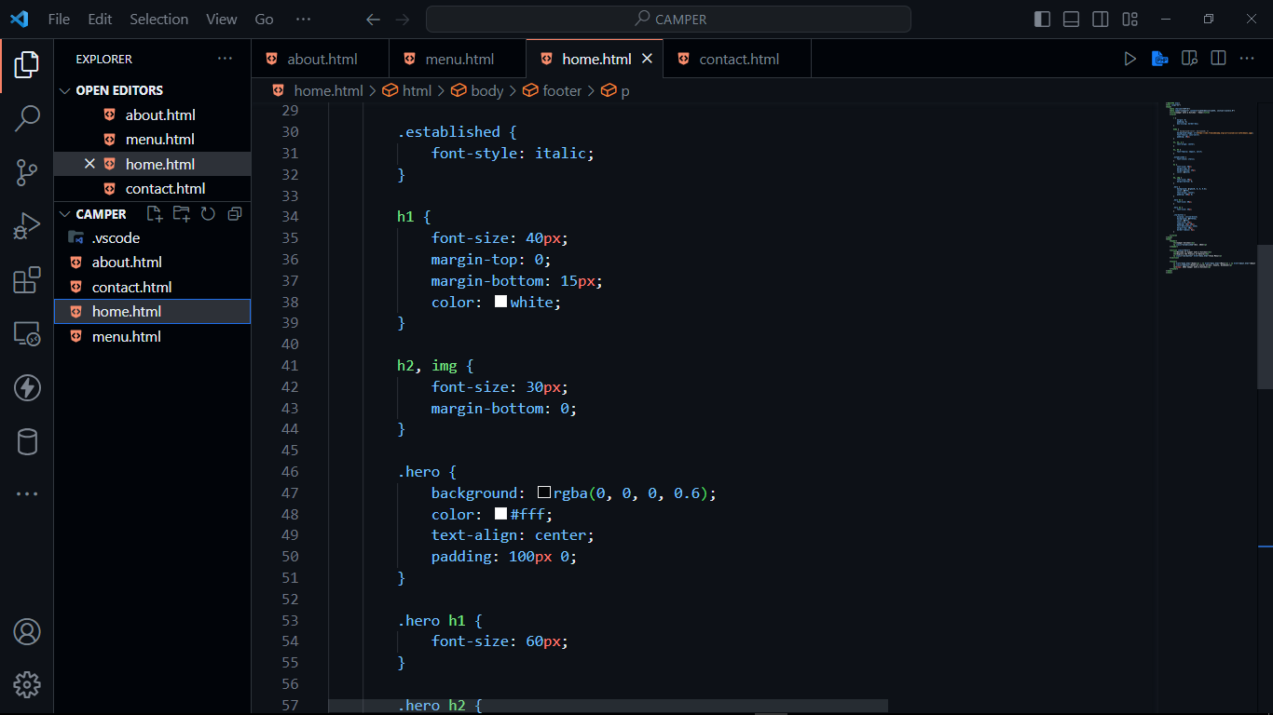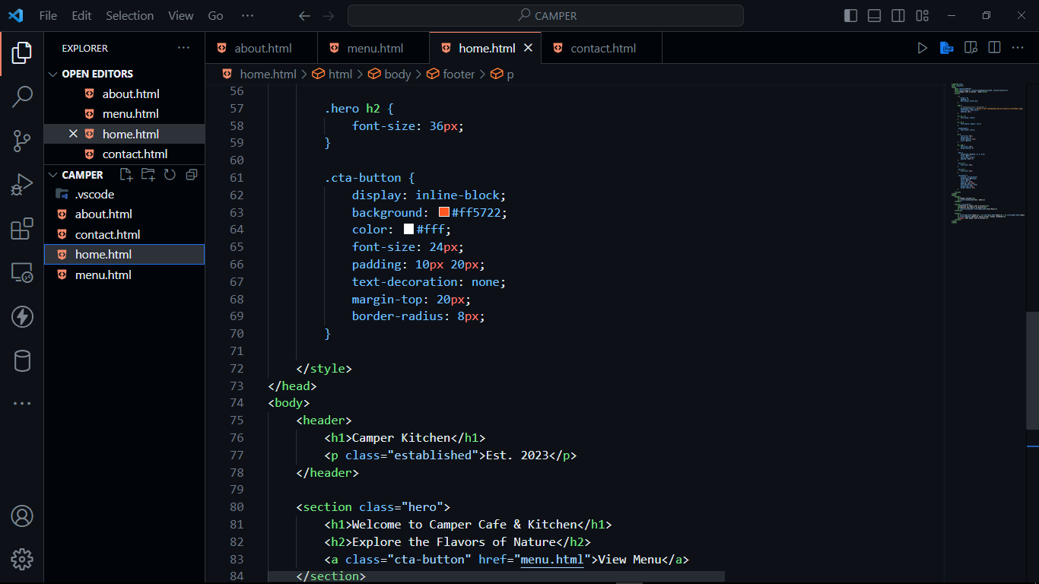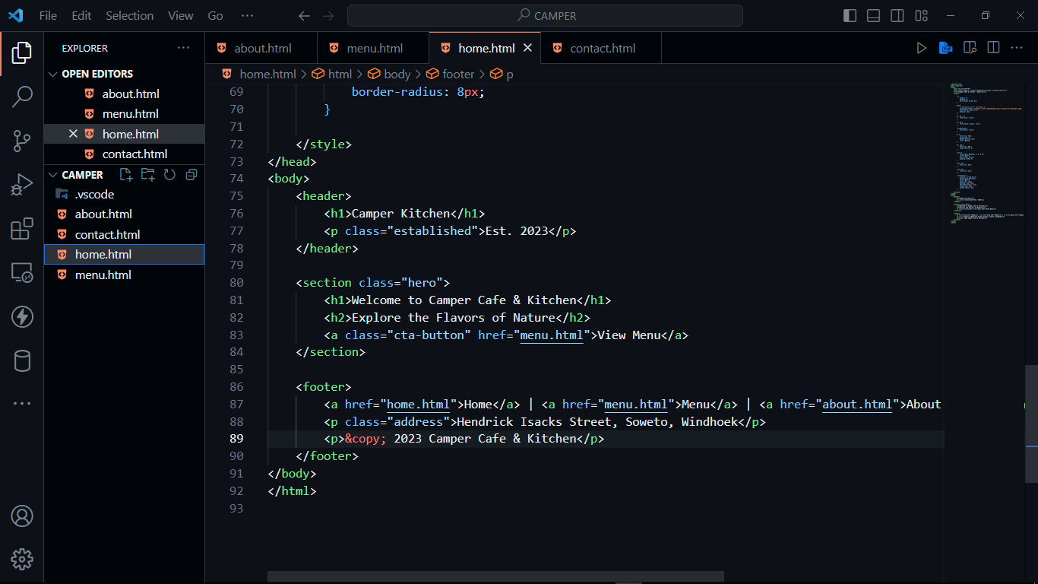

**Menu Page**

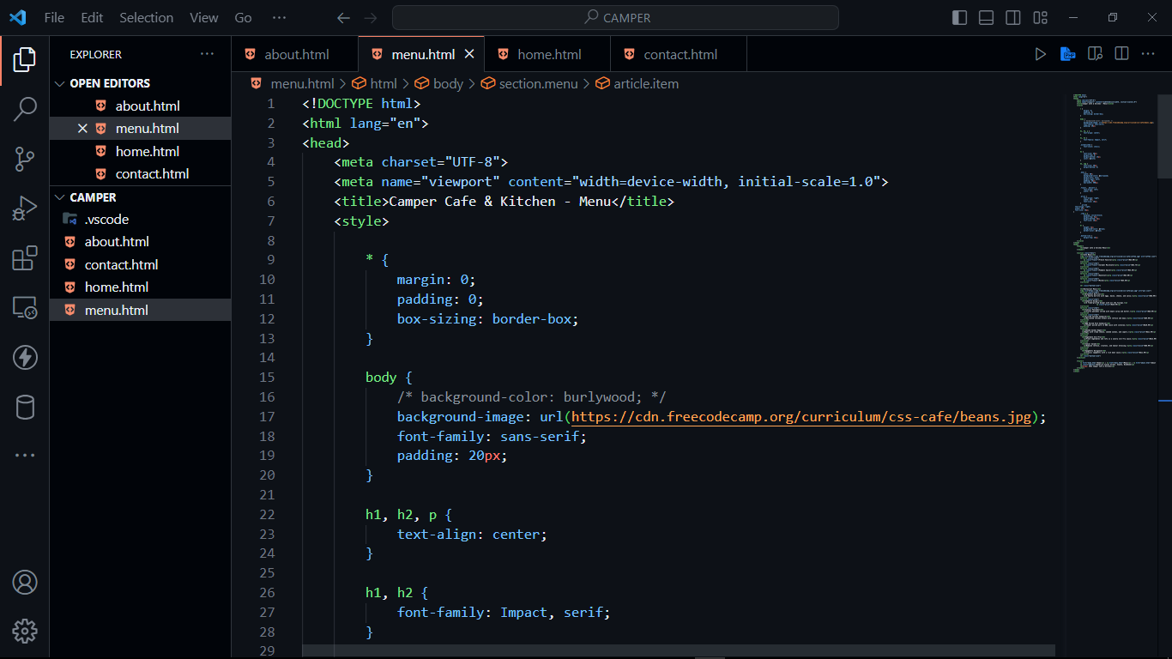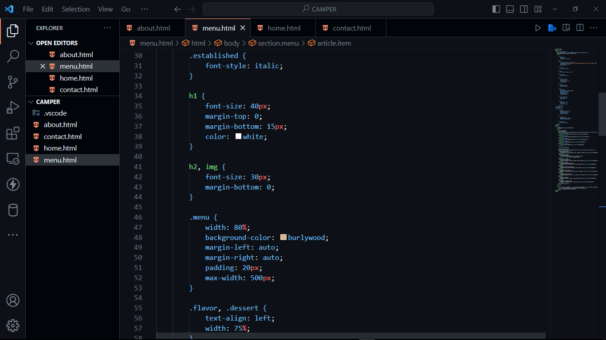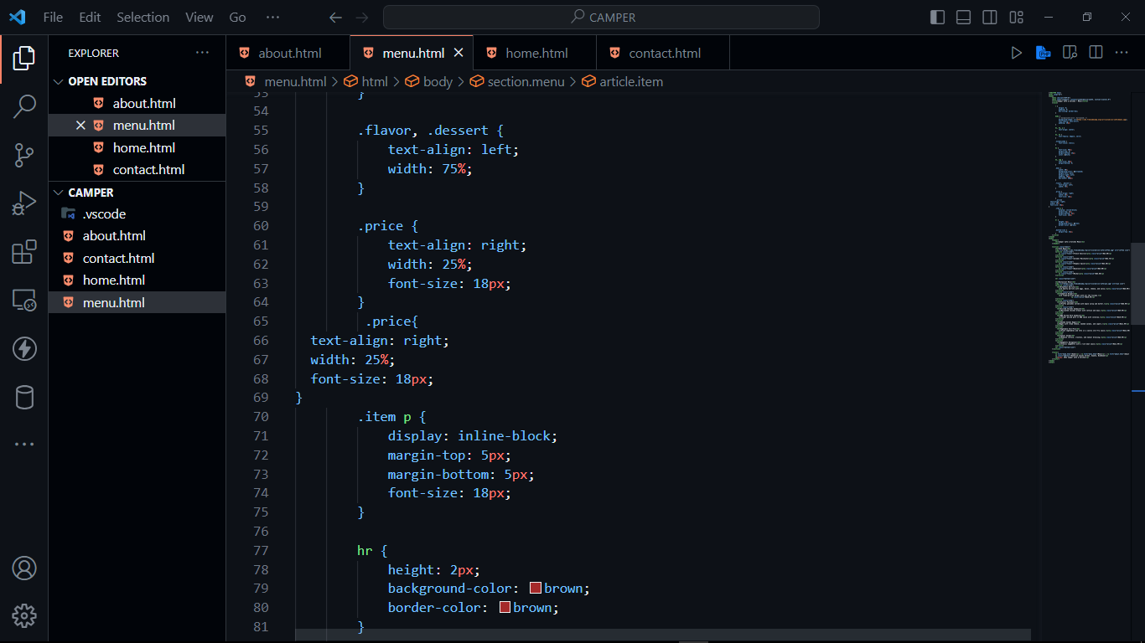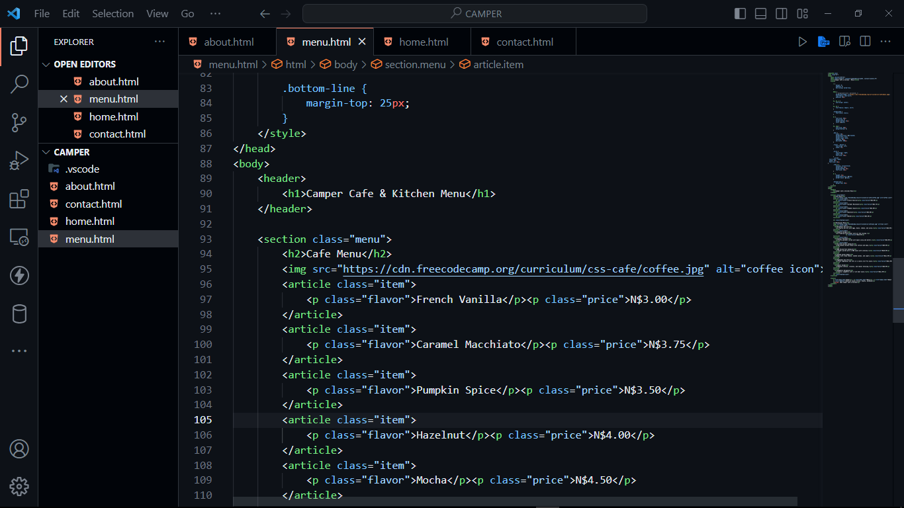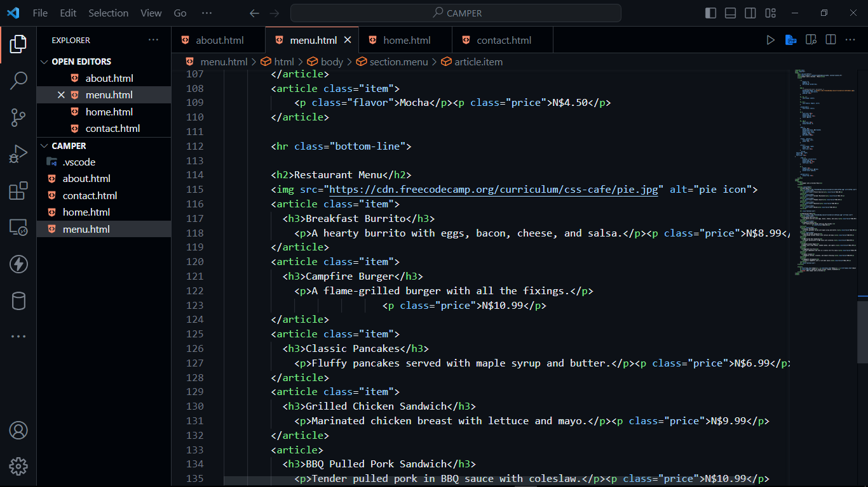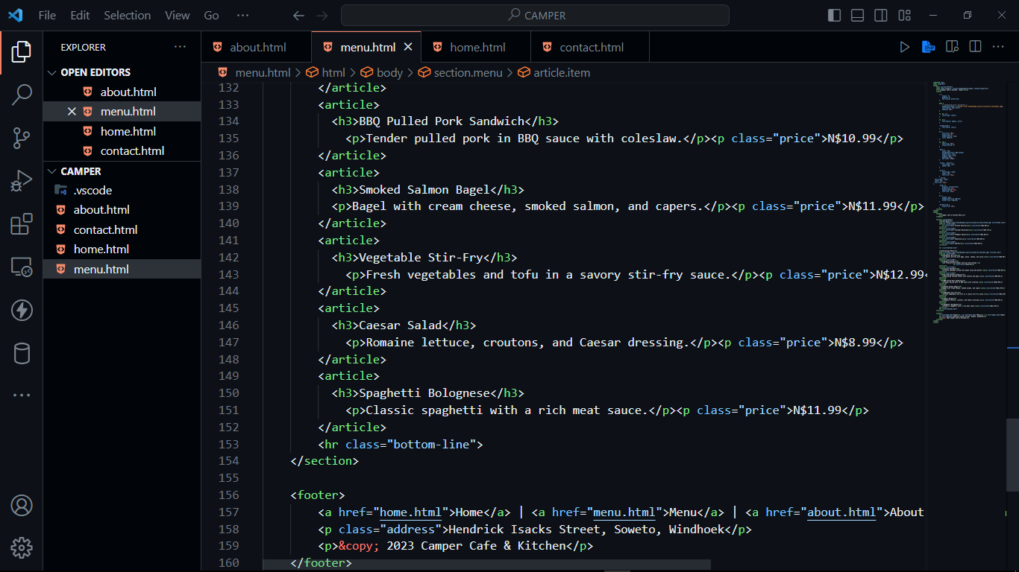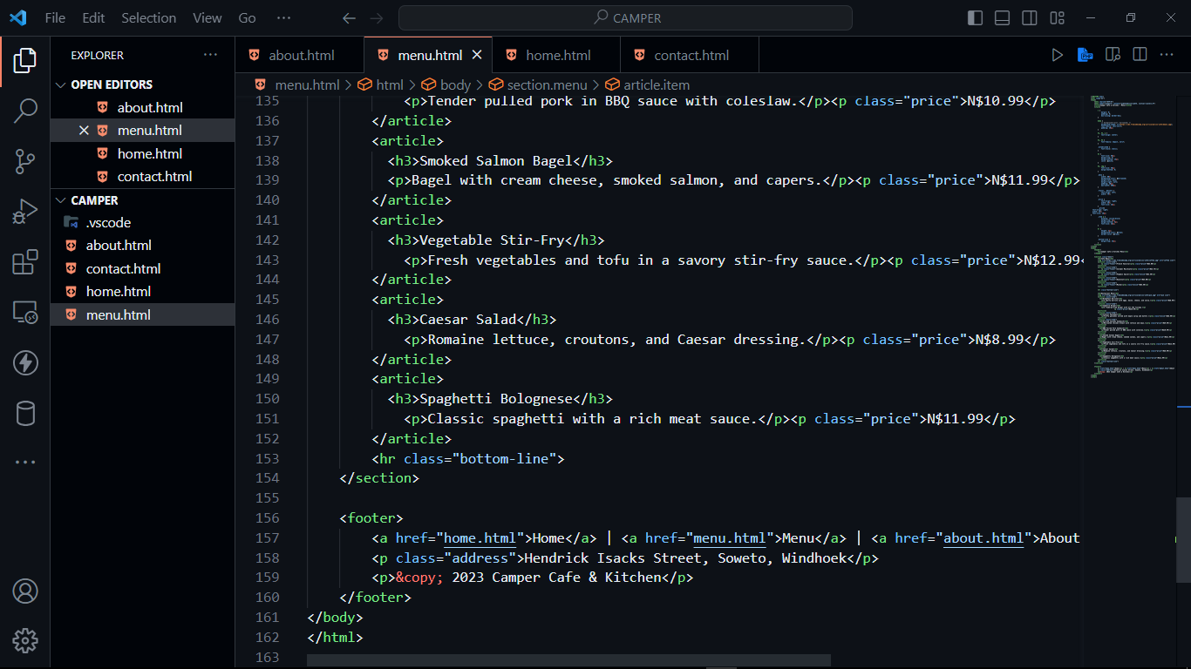

**About US Code**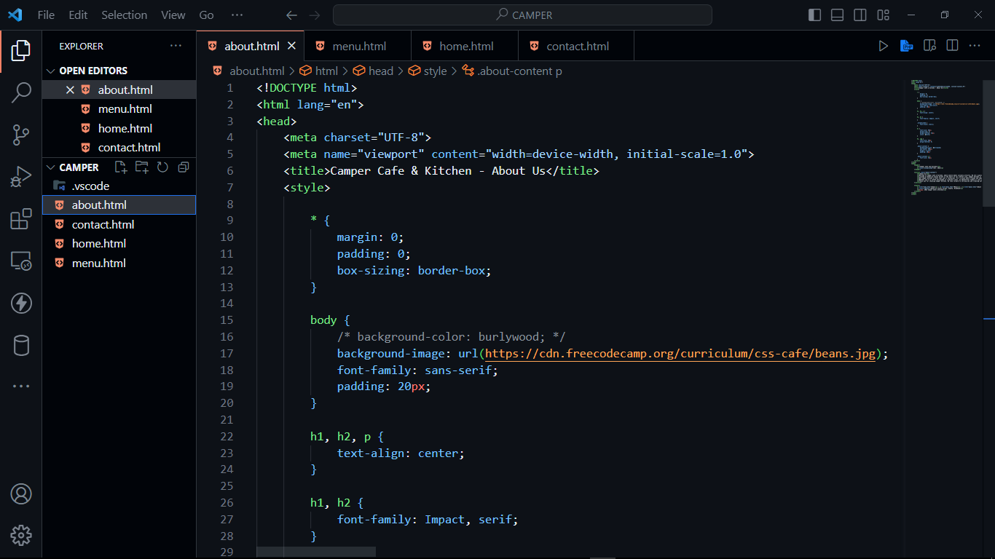

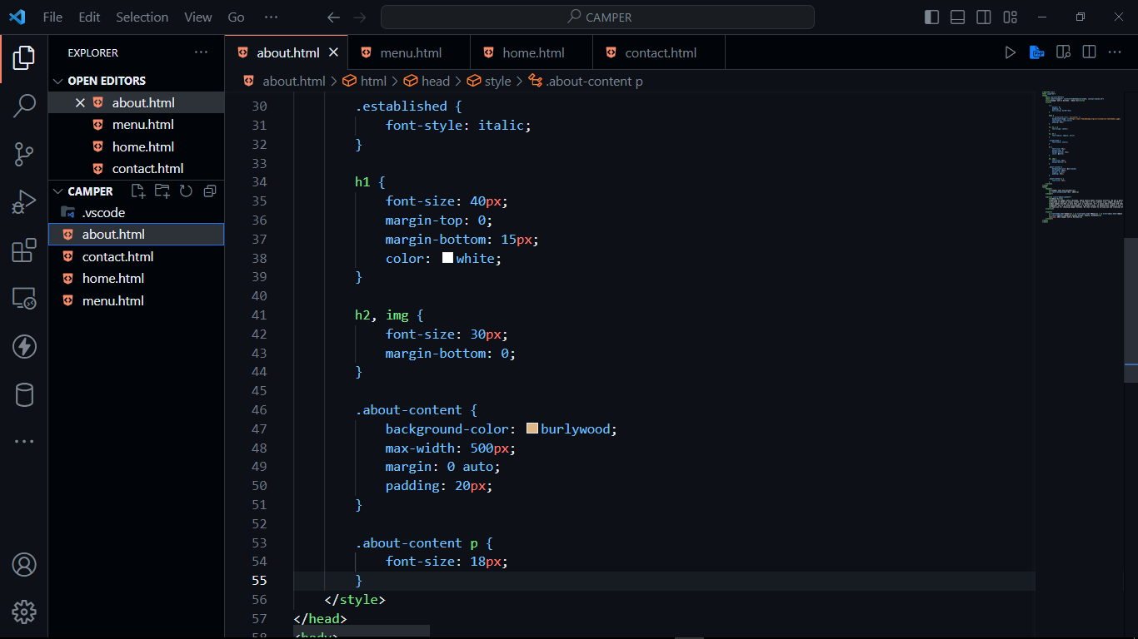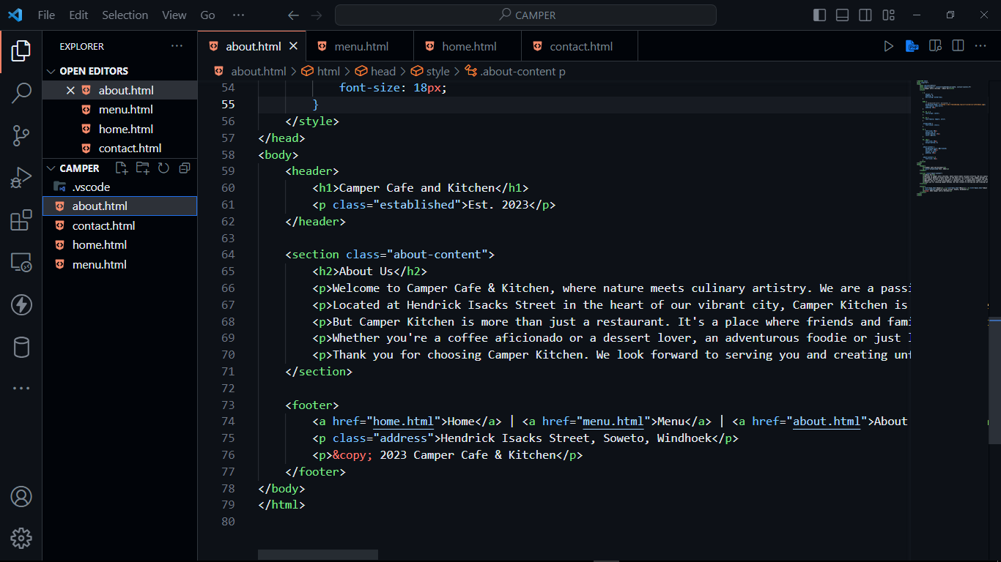

Contact Us

